**DS4Windows**

Step 1 – Install DS4Windows via their website (<https://ds4-windows.com>) OR github (<https://github.com/Ryochan7/DS4Windows>)

Step 2 – Install .NET Deskop Runtime if needed

Step 3 – Extract and run the DS4 application file.

Step 4 – You will be prompted to choose a save location, here either is fine.

Step 5 – Select “Step 1” and install the Driver. Click “Finished” once completed.

Step 6 – Click next and you’ll be greeted by the following screen once the controller is connected.

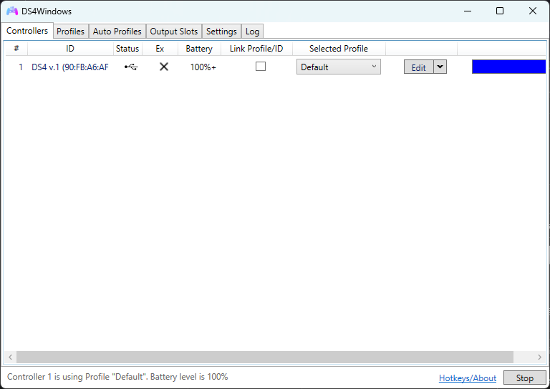

**SixaxisPairTool**

Step 1 - Install SixaxisPairTool from their website by clicking the download button on the right side. (<https://sixaxispairtool.en.lo4d.com/windows>)

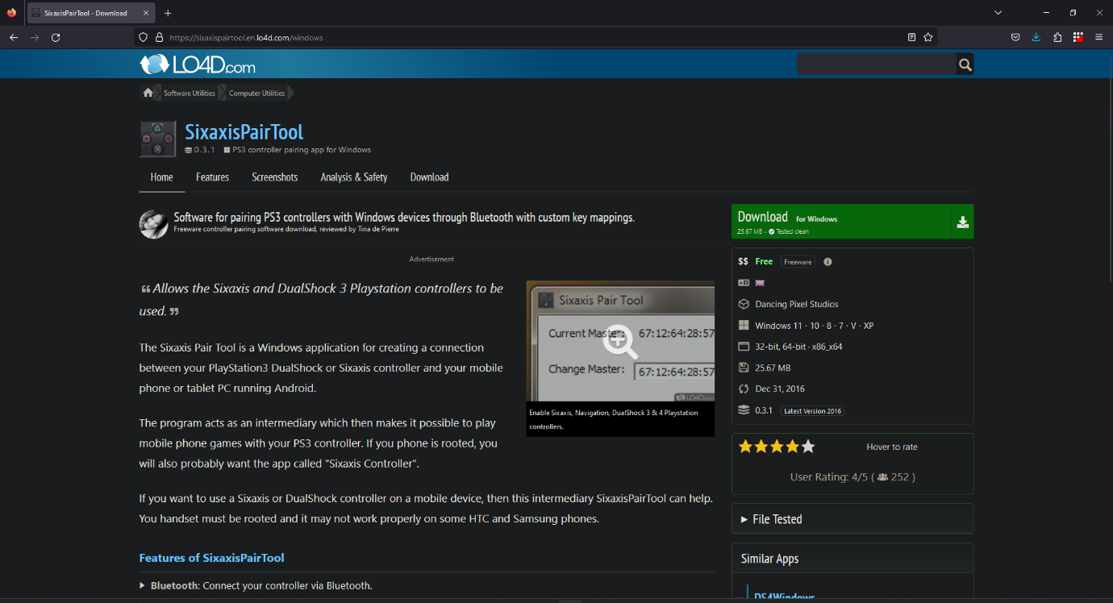

Step 2 – Choose the first mirror and the software should automatically start downloading.

Run the setup file and select options as prompted.

Step 3 – You will be asked to restart your device and will be greeted by this window when you run the application.

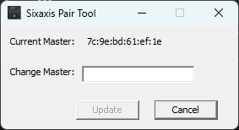

**Notes:**

• We have a total of 4 DualShock Controllers here, named D4-1, D4-2, D4-3, and D4-4. The "D4" in their names stands for DualShock 4.

• D4-1 and D4-2 are exclusively reserved for the competition, while D4-3 and D4-4 are used for testing purposes.

• It is important to fully charge the DualShock controllers at least once every two weeks. However, when they are actively being used, they should be charged at least once a week.

• The hierarchy of the D4 controllers' conditions follows their naming order, meaning D4-1 is superior to D4-2, D4-2 is superior to D4-3, and D4-3 is superior to D4-4.

• Due to wear and tear over the years, the thumb sticks of D4-4 have developed stick drift.

• We use DS4 Windows to assess the battery percentage and SixaxisPairTool to Change it’s MAC ID to ensure disruption free usage.

• To connect the DualShock 4 to the Laptop, you will need a power-cum-data cable. A simple power cable will not suffice.

•The DS4 battery discharges quickly (4 to 6 hours).